Lab7 CIS43 Due: 7/5/2016

Name: Nikhil Vytla

***Exercise: Ex 8.4, 8.6, 8.14***

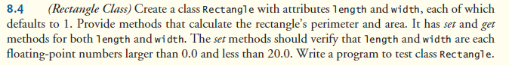

Rectangle

**package** P84;

**public** **class** Rectangle {

**private** **double** length;

**private** **double** width;

**public** Rectangle()

{

**this**.length = 1;

**this**.width = 1;

}

**public** **double** perimeter(**double** length, **double** width)

{

**double** perimeter = 2 * (**this**.getLength() + **this**.getWidth());

**return** perimeter;

}

**public** **double** area(**double** length, **double** width)

{

**double** area = **this**.getLength() * **this**.getWidth();

**return** area;

}

**public** **void** setLength(**double** length)

{

**if**(length < 0.0 || length > 20.0)

**throw** **new** IllegalArgumentException("length must be > 0.0 & < 20.0");

**this**.length = length;

}

**public** **void** setWidth(**double** width)

{

**if**(width < 0.0 || width > 20.0)

**throw** **new** IllegalArgumentException("width must be > 0.0 & < 20.0");

**this**.width = width;

}

**public** **double** getLength()

{

**return** length;

}

**public** **double** getWidth()

{

**return** width;

}

}

-------------------------------------------------

RectangleTest

**package** P84;

**import** java.util.Scanner;

**public** **class** RectangleTest {

**public** **static** **void** main(String[] args) {

Scanner input = **new** Scanner(System.*in*);

Rectangle rect = **new** Rectangle();

**try**

{

System.*out*.print("Enter a length: ");

**double** l = input.nextDouble();

rect.setLength(l);

System.*out*.print("Enter a width: ");

**double** w = input.nextDouble();

rect.setWidth(w);

System.*out*.printf("%nThe perimeter is: %n%.2f%n", rect.perimeter(rect.getLength(), rect.getWidth()));

System.*out*.printf("%nThe area is: %n%.2f", rect.area(rect.getLength(), rect.getWidth()));

}

**catch** (IllegalArgumentException e)

{

System.*out*.printf("Exception: %s%n%n", e.getMessage());

}

}

}

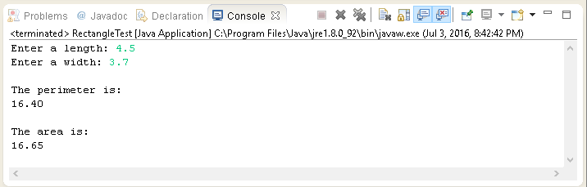

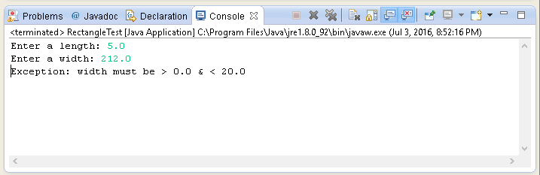

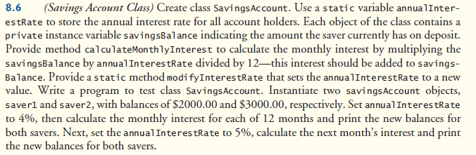

SavingsAccount

**package** P86;

**public** **class** SavingsAccount {

**private** **static** **double** *annualInterestRate* = 0.04;

**private** **double** savingsBalance;

**public** **double** calculateMonthlyInterest()

{

**double** monthInt = (getSavingsBalance() * *annualInterestRate*) / 12;

savingsBalance = (monthInt + getSavingsBalance());

**return** (savingsBalance);

}

**public** **static** **void** modifyInterestRate()

{

*annualInterestRate* = 0.05;

}

**public** **double** getSavingsBalance() {

**return** savingsBalance;

}

**public** **void** setSavingsBalance(**double** savingsBalance) {

**this**.savingsBalance = savingsBalance;

}

}

-------------------------------------------------

SavingsAccountTest

**package** P86;

**public** **class** SavingsAccountTest {

**public** **static** **void** main(String[] args) {

SavingsAccount saver1 = **new** SavingsAccount();

SavingsAccount saver2 = **new** SavingsAccount();

saver1.setSavingsBalance(2000.00);

saver2.setSavingsBalance(3000.00);

System.*out*.printf("Annual interest rate: 0.04%n");

System.*out*.printf("%nsaver1%nOriginal Balance: $%6.2f%n", saver1.getSavingsBalance());

System.*out*.printf("%5s%20s", "Month", "Savings Balance");

**for** (**int** month = 1; month <= 12; month++)

{

System.*out*.printf("%n%5d%20.2f", month, saver1.calculateMonthlyInterest());

}

System.*out*.printf("%nsaver2%nOriginal Balance: $%6.2f%n", saver2.getSavingsBalance());

System.*out*.printf("%5s%20s", "Month", "Savings Balance");

**for** (**int** month = 1; month <= 12; month++)

{

System.*out*.printf("%n%5d%20.2f", month, saver2.calculateMonthlyInterest());

}

System.*out*.printf("%n%nNow, let's set the annual interest rate to 0.05%n%n");

saver1.*modifyInterestRate*();

System.*out*.printf("saver1 - NEW YEAR%n");

System.*out*.printf("%5s%20s", "Month", "Savings Balance");

System.*out*.printf("%n%5d%20.2f%n", 1, saver1.calculateMonthlyInterest());

System.*out*.printf("%nsaver2 - NEW YEAR%n");

System.*out*.printf("%5s%20s", "Month", "Savings Balance");

System.*out*.printf("%n%5d%20.2f%n", 1, saver2.calculateMonthlyInterest());

}

}

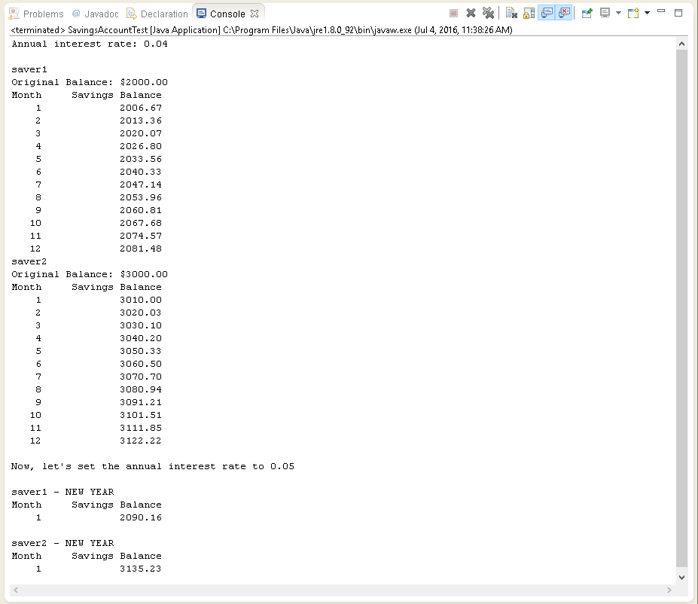

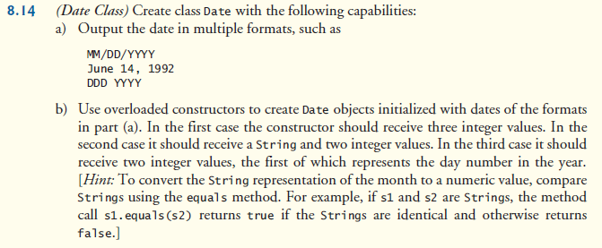

Date

**package** P814;

**public** **class** Date {

**private** **int** month;

**private** **int** day;

**private** **int** year;

**private** **int** days;

**private** **static** **final** **int**[] *daysPerMonth* =

{ 0, 31, 28, 31, 30, 31, 30, 31, 31, 30, 31, 30, 31 };

**private** **static** **final** String[] *monthsPerYear* =

{ "January", "February", "March", "April", "May", "June", "July", "August", "September", "October", "November", "December" };

**public** Date(**int** month, **int** day, **int** year)

{

**if** (month <= 0 || month > 12)

**throw** **new** IllegalArgumentException(

"month (" + month + ") must be 1-12");

**if** (day <= 0 ||

(day > *daysPerMonth*[month] && !(month == 2 && day == 29)))

**throw** **new** IllegalArgumentException("day (" + day + ") out-of-range for the specified month and year");

**if** (month == 2 && day == 29 && !(year % 400 == 0 ||

(year % 4 == 0 && year % 100 != 0)))

**throw** **new** IllegalArgumentException("day (" + day + ") out-of-range for the specified month and year");

**this**.month = month;

**this**.day = day;

**this**.year = year;

}

**public** Date(String month_of_year, **int** day, **int** year)

{

**this**.month = 0;

**for** (**int** i = 0; i < 12; i++)

{

**if** (*monthsPerYear*[i].equals(month_of_year))

{

**this**.month = i + 1;

**break**;

}

}

**if** (month <= 0 || month > 12)

**throw** **new** IllegalArgumentException(

"month (" + month_of_year + ") must be " + *monthsPerYear*[0] + " to " + *monthsPerYear*[11]);

**if** (day <= 0 ||

(day > *daysPerMonth*[month] && !(month == 2 && day == 29)))

**throw** **new** IllegalArgumentException("day (" + day + ") out-of-range for the specified month and year");

**if** (month == 2 && day == 29 && !(year % 400 == 0 ||

(year % 4 == 0 && year % 100 != 0)))

**throw** **new** IllegalArgumentException("day (" + day + ") out-of-range for the specified month and year");

**this**.day = day;

**this**.year = year;

}

**public** Date(**int** days, **int** year)

{

**if** (days <= 0 || days > 365)

**throw** **new** IllegalArgumentException(

"days (" + days + ") must be 1-365");

**this**.days = days;

**this**.year = year;

}

**public** String toString()

{

**return** String.*format*("%02d/%02d/%04d", month, day, year);

}

**public** String toLongDate()

{

**return** String.*format*("%s %02d, %04d", *monthsPerYear*[month - 1], day, year);

}

**public** String daysOfYear()

{

**return** String.*format*("%03d %04d", days, year);

}

}

-------------------------------------------------

DateTest

**package** P814;

**public** **class** DateTest {

**public** **static** **void** main(String[] args) {

Date d1 = **new** Date(12, 28, 1864);

Date d2 = **new** Date("November", 14, 2009);

Date d3 = **new** Date(345, 1997);

System.*out*.println(d1.toString());

System.*out*.println(d2.toLongDate());

System.*out*.println(d3.daysOfYear());

}

}

